

UNIVERSITY OF BUEA
FACULTY OF ENGINEERING AND TECHNOLOGY
DEPARTMENT OF COMPUTER ENGINEERING
CEF440: INTERNET PROGRAMMING AND MOBILE PROGRAMMING

PROJECT TITLE: DESIGN AND IMPLEMENTATION OF AN ADAPTIVE E-LEARNING PLATFORM BASED ON QUALITY OF EXPERIENCE FOR INCLUSIVE ONLINE EDUCATION IN LOW – RESOURCE SETTINGS.

TASK 5
Group 15 Report
COURSE INSTRUCTOR: Dr Nkemeni Valery

NAME | MATRICULE
NJINYA NGECHA RYAN BROWN | FE23A116
KARL JONAS WENGE ACHA | FE23A072
BRIANNA TEBESICK TSAMO | FE23A028
KELSEY NJOCK-AWOH NJOCK OBEN | FE23A073

8th June 6, 2026
INTRODUCTION
This report presents the User Interface (UI) Design and Implementation phase of the project titled Design and Implementation of an Adaptive E-learning Platform Based on Quality of Experience (QoE) for Inclusive Online Education in Low-Resource Settings.
The purpose of this task is to design and implement an intuitive, responsive, and user-friendly interface that meets the requirements identified during the requirement analysis phase. The UI design focuses on providing accessible learning experience for learners, instructors, parents, and administrators while ensuring compatibility with mobile devices and low-bandwidth environments.
The implementation was carried out using modern frontend technologies to create responsive web pages, interactive components, and a consistent visual identity for the platform.
App Identity
The application is called LearnBridge, an adaptive e-learning platform designed for learners, instructors, parents, and administrators. The platform aims to provide accessible online education in low-resource environments. The brand identity focuses on accessibility, adaptability, engagement, trust, and simplicity.
Logo Concept

The logo combines education and technology concepts. It represents knowledge sharing, online learning, and connectivity between learners and instructors.
Brand Identity
The platform was designed with a modern educational identity that reflects:
- Accessibility
- Simplicity
- Reliability
- Inclusiveness
- Innovation
The branding aims to create a welcoming learning environment that encourages engagement , adaptative learning and effective knowledge acquisition
Visual Design
This explains how the application looks.
Color | Purpose
Deep Dark Navy Blue | Establishes authority, creates a premium enterprise feel.
Vibrant Teal / Cyan | Draws immediate focus to high-priority items, interactive states, and healthy operational vectors.
Crisp Bright White | Maximizes contrast and readability for text and numerical statistics while maintaining a clean, professional aesthetic.
Soft Gray | Lowers visual noise and prevents cognitive overload by "dimming" static labels so that the changing data values pop out.
Orange | Indicates resource consumption or approaching limits without triggering the immediate panic of a critical red error.

Orange is used to attract attention to important actions. Gray creates a clean and modern interface.
TYPOGRAPHY
The platform uses modern readable fonts to improve user experience across mobile phones, tablets, and desktop computers.
User Interface Components
The platform includes the following UI components:
Navigation Bar
Provides access to:
- Dashboard
- Courses
- Assessments
- Attendance
- Messages
- Profile
Dasboard
Displays:
- Course progress
- Recent activities
- Upcoming lessons
- Notifications

Course Cards
Each course card displays:
- Course title
- Instructor name
- Progress status
- Quick access button

Assessment Interface
Allows learners to:
- View quizzes
- Submit answers
- Receive scores

Progress Tracking Panel
Displays:
- Learning progress
- Attendance records
- Performance statistics

Parent Dashboard
Allows parents to:
- Monitor learner activities
- View performance reports
- Track attendance

Administrator Dashboard
Provides:
- User management
- Course management
- Report generation
- System monitoring

Responsive Design
The interface was designed using responsive layouts to support:
- Smartphones
- Tablets
- Laptops
- Desktop computers
Responsive design techniques such as flexible grids, media queries, and adaptive layouts were used to ensure a consistent user experience across different screen sizes.
Frontend Implementation
Technology used
Technology used | Purpose
React 19 | User Interface
Next.js 16 | Application Framework
Typescript | Type safety
Tailwind CSS | Styling
Lucide React, Zustand | Icons, State Management

AUTHENTICATION SYSTEM
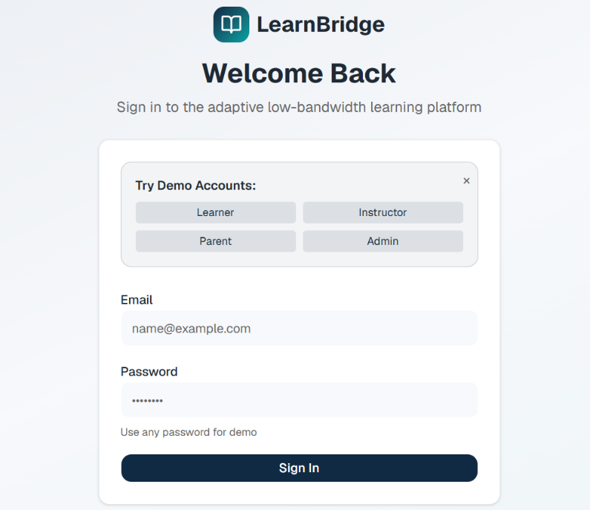
A login system was implemented using Zustand state management. Users can authenticate and access features according to their assigned roles.
Learner Dashboard
Features:
- Course Progress
- Active Courses
- Learning Resources
- Live Classes
- Performance Statistics
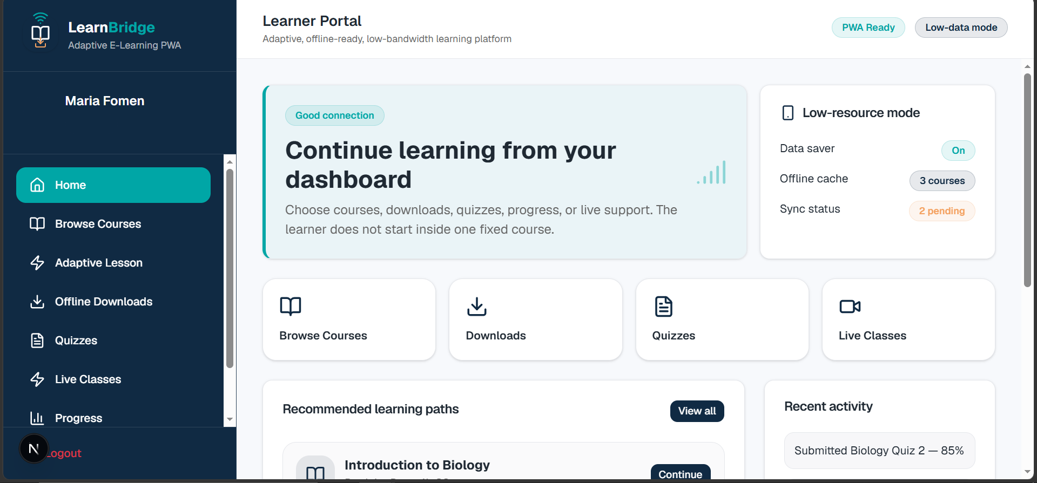
Instructor Dashboard
Features:
- Course Management
- Student Tracking
- Revenue Statistics
- Course Analytics
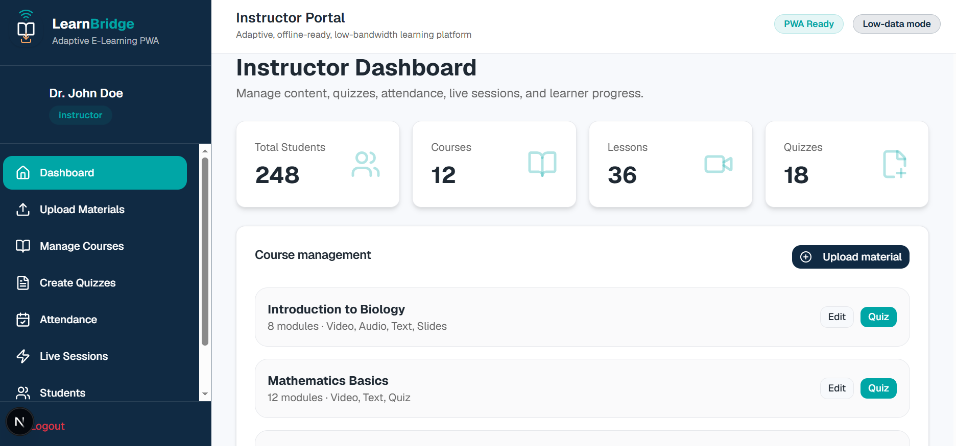
Parent Dashboard
Features:
- Child Monitoring
- Progress Reports
- Activity Tracking
- Learning Alerts
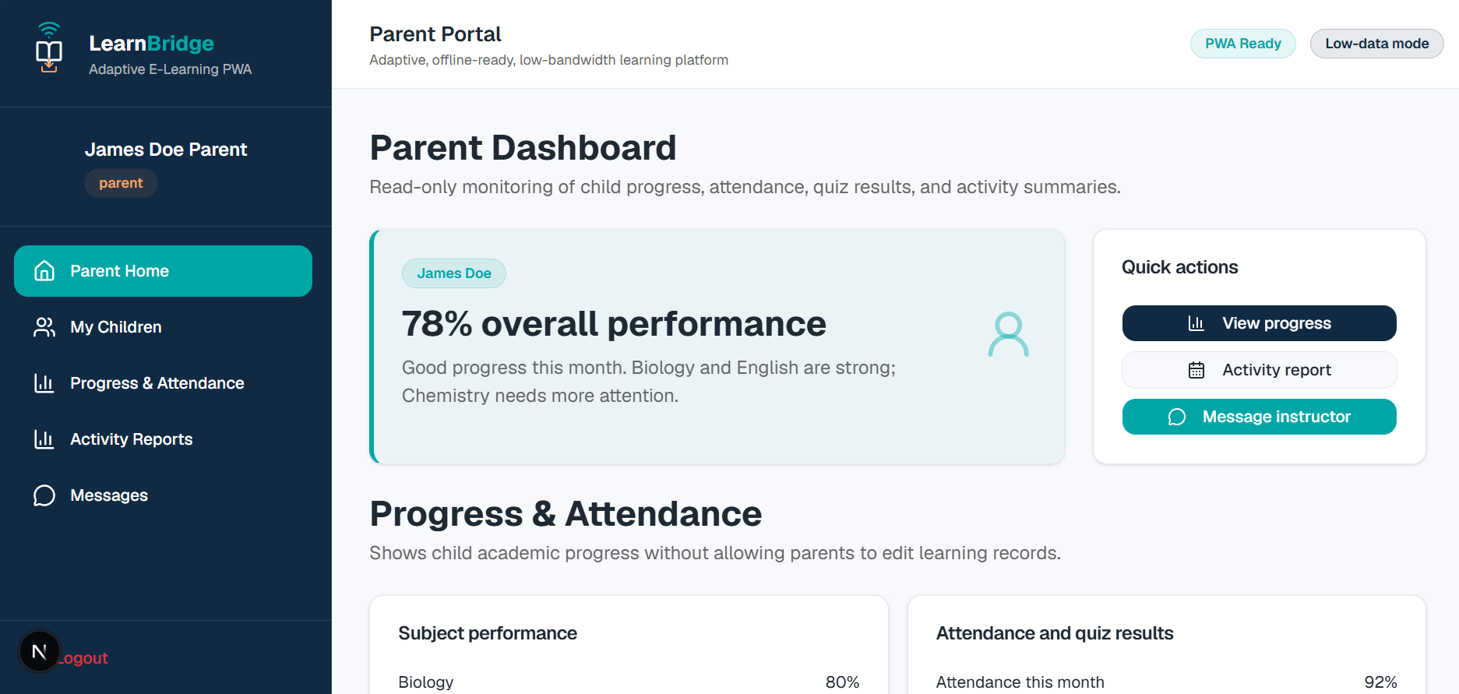
Administrator Dashboard
Features:
- User Management
- Platform Statistics
- Revenue Tracking
- System Monitoring
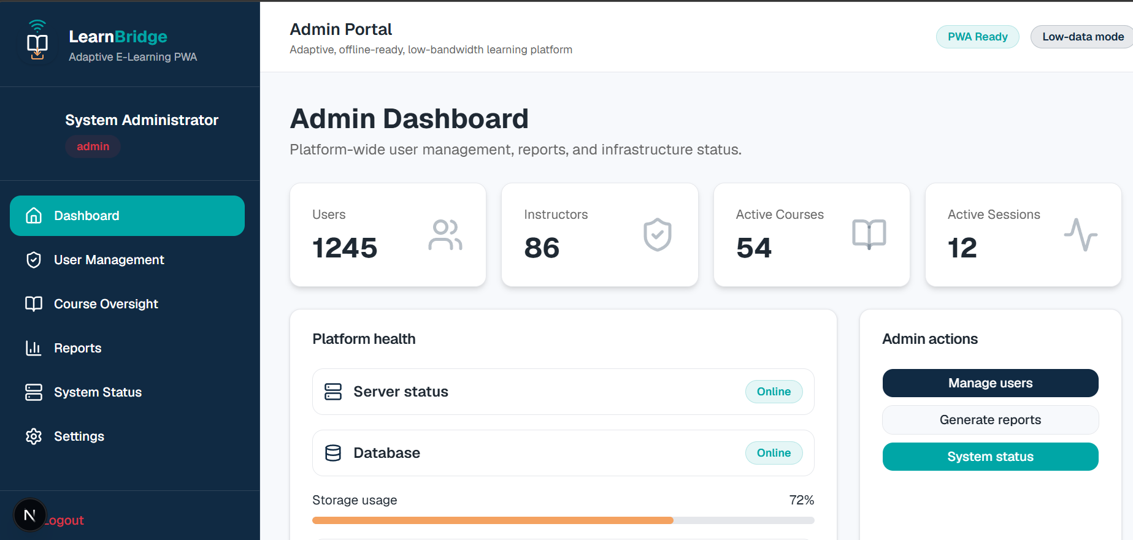
CONCLUSION
The frontend of LearnBridge was successfully implemented using React, Next.js, TypeScript, Tailwind CSS, and Zustand. The platform provides separate interfaces for learners, instructors, parents, and administrators. The implementation follows responsive design principles, ensuring accessibility across smartphones, tablets, and desktop devices. The completed interface provides an intuitive, scalable, and user-friendly environment for adaptive online learning in low-resource settings.

TABLE OF CONTENTS

